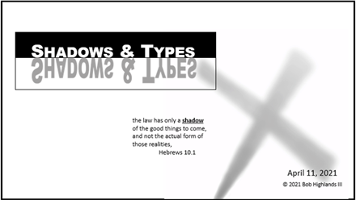
Week ONE – Study Guide
Shadows And Types - Intro
This week our study time is a review and a challenge. We will review 7 of this scriptures from the message this week. The challenge is to see how they can be applied to the Christian walk and our beliefs.
“It is the way God has chosen to record history before it happens.” O.L. Johnson
- (Sunday) Hebrews 10.1 & Romans 5.14 How can shadows and types help us understand the word of God? Describe what a Biblical Shadow is and why we need to study them.

- (Monday) John 6.49-51 How does the Old Testament help us understand what Jesus is saying here?

- (Tuesday) John 3.14-15 Numbers 21.4-9 How many ways can you find that what happened in the wilderness here be seen as a shadow of the New Testament and Christ?

- (Wednesday) Matthew 12.40 Jonah 1.1-17 How does the 3 days and night in Jonah help us understand the significance of Jesus time in the grave? How is Jonah’s life not a shadow of Christ?

- (Thursday) Galatians 4.22-31 Genesis 16 How does this story help us see our relationship with God through Christ? How does this story help us see the conflict between physical and Spiritual?

- (Friday) Hebrews 6.19 Hebrews 7.3 Genesis 14.17-20 How does the New Testament help us understand this story and it’s significance to us as believers?

- (Saturday) 1 Corinthians 15.45-47 Romans 5.14; Romans 5.12; Hebrews 4.15 Who are the two Adams mentioned here. How are the two Adams similar? The different? Why is it helpful to understand the similarities and differences?

