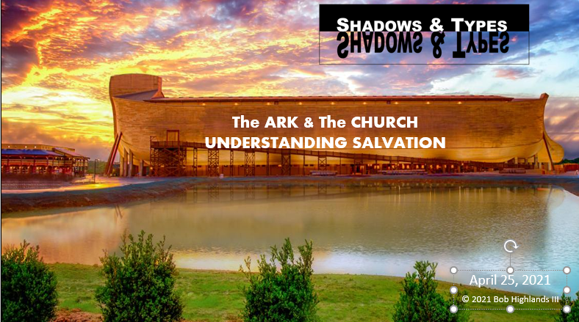
Genesis 6.5-8
God vs. Evil
♦ The eyes of the LORD watch over those who do right; his ears are open to their cries for help. But the LORD turns his face against those who do evil; he will erase their memory from the earth. Psalm 34.15
1. The LORD _____________ the extent of human wickedness.
2. He saw that _____________ they thought or imagined was consistently and totally evil.
3. It broke his _____________ .
4. I will _____________ this human race I have created from the face of the earth.
5. _____________ Noah found _____________ with the LORD.

Noah A type of Christ
both Preachers of Righteousness

♦ _____________ is remaining _____________ of sin while living your life for God.
♦ God “did not spare the ancient world when he brought the flood on its ungodly people, but protected Noah, a preacher of ________________ …” 2 Peter 2.5
♦ Jesus’ _____________ to turn from sin and live a life of _____________ .
♦ From that time Jesus began to _____________, saying, Repent, for the kingdom of heaven is at hand.” Matthew 4.17

Noah A type of Christ
Foolish Preaching vs. Preaching Foolishness

♦ Preaching Righteousness is seen as ____________ and often ignored by those who need it if they are going to be saved.
♦ God “did not spare the ancient world when he brought the flood on its ungodly people, but protected Noah, a preacher of ________________ …” 2 Peter 2.5
♦ God has chosen to use what the world sees as ________________ to bring the message to them.
♦ Since God in his wisdom saw to it that the world would never know him through human wisdom, he has used our ________________ preaching to save those who believe.
1 Corinthians 1.21

Noah A type of Christ
They both Preached Salvation

♦ The reason for ________________ is to warn and provide a way of escape. Noah preached and no one listened.
♦ God “did not spare the ancient world when he brought the flood on its ungodly people, but protected Noah, a ________________ of righteousness…” 2 Peter 2.5
♦ God chose ________________ over miracles, signs, wonders as the method to deliver the message of mercy and grace.
♦ For “everyone who calls on the name of the Lord will be SAVED.”
…how are they to hear without someone ________________ ? Romans 10.14-15

Noah A type of Christ
They both offer REST.

♦ Noah was over _______ years old when He started building the Ark for God and was _______ years old when the flood came.
♦ After Noah was _______ years old, Noah fathered Shem, Ham, and Japheth. Genesis 5.29 & Genesis 7.6
♦ NOAH means ________________ or COMFORT.
♦ Then JESUS said, "Come to me, all of you who are weary and carry heavy burdens, and I will give you ________________ . Matthew 11.28 ^{see also Hebrews 4.9-11}

Noah A type of Christ
Both lived Righteous Lives

♦ The ________________ of Noah was an example of how God wanted everyone to live.
♦ Noah was a ________________ man, the only ________________ person living on earth at the time, and he walked in close fellowship with God. Genesis 6.9
♦ The ______________ of Jesus was perfect. He was without ______!
♦ Christ, the ______________ , spotless Lamb of God. 1 Peter 1.18
♦ …one who in every respect has been tempted as we are, yet ________________ _______. Hebrews 4.15

The Ark and the Church
Inhabitants determined by preaching.

♦ By rejecting the ________________ of the Word of God as preached by Noah they were sealing their fate before God and were not allowed in the ark.
♦ God “did not spare the ancient world when he brought the flood on its ________________ people, but protected Noah, a preacher of righteousness…” 2 Peter 2.5
♦ The ________________ of the ________________ of God is the ________________ of the ________________ of GOD. The response determines membership in the Kingdom and into the church.
♦ We faithfully ________________ the ________________ . God's power is working in us. 2 Corinthians 6.7NLT

The Ark and the Church
There is only one way in

♦ The only way to get into the ark was through the _______ in its side.
♦ …set the ________________ of the ark in its side. Genesis 6.19
♦ The ________________ way into the church is through the ________________ , and Jesus is that ________________ .
♦ I am the ________________ . If anyone enters by me, he will be saved John 10.9 ESV
♦ Jesus told him, "I am the ________________ , the truth, and the life. No one can come to the Father except _______________ me. John 14.6 NLT

The Ark and the Church
The Mountain of God
♦ God put the ARK on the ________________ top because it prefigures the position of the church.
♦ in the seventh month, on the seventeenth day of the month, the ark came to rest on the ________________ of Ararat. Genesis 8.4
♦ The church is not the same thing as the denominations. There is only one ________________ church.
♦ In the last days, the ________________ of the LORD's house will be the highest of all– the most important place on earth. It will be raised above the other hills, and people from all over the world will stream there to worship. ^{IS 2.2}

The Ark and the Church
There was only one Window

♦ There was only ________ ________________ , and it was on the top of the Ark. This was their source of light.
♦ …Noah opened the ________________ of the ark that he had made. Genesis 8.6
♦ Jesus is the ________________ and the ________________ for the church (believers) in this dark world.
♦ Jesus said, "I am the ________________ of the world. If you follow me, you won't have to walk in darkness, because you will have the ________________ that leads to life.“ John 8.12

The Ark and the Church
Both are made to endure the Storm

♦ God ________________ the Ark to withstand the harsh storms. They were on the Ark for one year.
♦ Make yourself an ark of gopher wood. Make rooms in the ark, and ________________ it inside and out with pitch. Genesis 6.14
♦ Jesus ________________ the Church to withstand the battle against evil. Remember gates don’t move so the church is designed to take the battle to the enemy.
♦ I will build MY ________________ , and the gates of hell shall not ________________ against it. Matthew 16.18

The Ark and the Church

♦ Noah and his family were ________________ from the world in the ark.
♦ The call of the church is to “come out from among unbelievers, and ________________ yourselves from them, 2 Corinthians 6.17
♦ Noah and his family became heirs of the ______ ________________ free from sin.
♦ We will inherit what God has promised is to come. Then I saw a ______ ________________ and a ______ ________________ , for the old heaven and the old earth had disappeared. And the sea was also gone. Revelation 21.1

The Ark and the Church

♦ ________________ Eight people were saved because the entered the ark. Genesis 7.7
♦ The ________________ way into the church is through the new birth. “I tell you the truth, unless you are ________________ FROM ________________ , you cannot see the Kingdom of God.“ John 3.3
♦ They had to ________________ in the Ark until God brought them safely to the new world.
♦ You are ____________ _________ so you need to not fall away (Heb. 6.4-6) For we are the aroma_ of Christ to God among those who are ______________ _________ …
(2 Corinthians 2.15)

The Ark and the Church
♦ Noah and his family waited in the Ark seven days before it started to rain. Genesis 7.10
They must have looked ________________ to the world of people around them. We will inherit what God has promised is to come.
♦ “God chose what is ________________ in the world to shame the wise… Let the one who boasts, boast in the Lord.”
1 Corinthians 1.27 & 31

The Ark and the Church
Eagerly waiting for Him

♦ When the door of the Ark was ________________ no one else could come in. Judgment was complete and Justice was final.
♦ At the END of this life, whether by our death or the Lord’s return…“
♦ “And just as it is appointed for man to die once, and after that comes judgment, so Christ, having been offered once to bear the sins of many, will appear a second time, not to deal with sin but to ________________ those who are eagerly ________________ for him.” Hebrews 9.27-28

The Ark and the Church
Discovering God as your Rudder

♦ The Ark did not have a ________________ ! God decided where it was to go and where he wanted it to land.
♦ We are not without a ________________ ; God is our rudder and determines our course.
the ________________ shall live by HIS ________________ .
Habakkuk 2.4
Romans 1.17
Galatians 2.2l
Galatians 3.11
Hebrews 10.38

