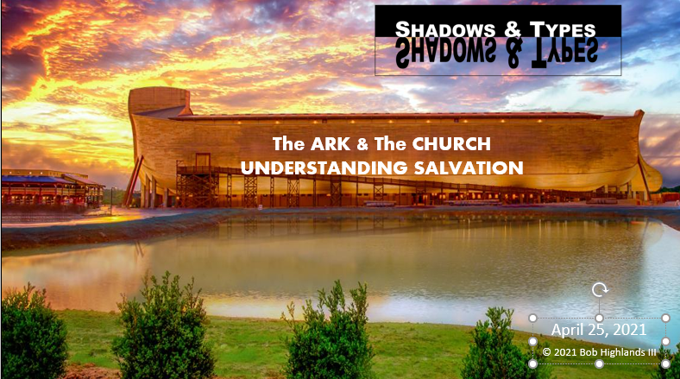
Sonrise Noah Bible quiz

This week I have put together a Quiz for you to answer and work on. Here is the challenge. Can you answer the questions below and then can you find verse that shows us the answer? We will go over the quiz as part of our Bible study time on Wednesday. Best wishes and enjoy, but don’t stress, it is designed to be fun and yes it is also designed to challenge those of you who just need a real challenge.
Here is where to look for your answers. Genesis 6.5 through Genesis 9.17; 1 Peter 3.20 & 2 Peter 2.5
1.) Who was Noah's father?
Lamech
Abel
Seth
Enoch
2.) Which of these men was NOT a son of Noah?
Canaan
Japheth
Ham
Shem
3.) Why did the Lord want to destroy man?
Man was too wicked
Man was too smart
Man was too slothful
Man was too strong
4.) "... and Noah ___________ with God."
walked
taught
served
ate
5.) How would the Lord destroy mankind?
Earthquake
Fire
Flood
Famine
6.) What kind of wood did Noah use to build the ark?
Oak
Gopher
Mahogany
Cedar
7.) With what material would Noah coat the ark?
Straw
Animal fat
Grease
Tar
8.) What unit of measurement was used to measure the ark?
Cubit
Furlong
Beam
Meter
9.) How many stories high was the ark?
1; it was open and spacious
7
3
5
10.) Which humans boarded the ark?
Only Noah
Noah, Russell Crow and the cast from the unbiblical movie.
Noah and his wife and sons
Noah, his wife, and Noah's sons and their wives
11.) How many windows and doors were there in the ark?
One of each
One door and three windows
Two doors and three windows
The Bible does not say
12.) How many birds of each kind did Noah gather onto the ark?
7
10
4
2
13.) How long did it rain?
70 days and nights
10 days and nights
40 days and nights
80 days and nights
14.) How long did the water cover the entire earth?
150 days
100 days
40 days
50 days
15.) What was the first animal that Noah let out of the ark?
A dove
A sparrow
A raven
A pigeon
16.) How many times did the bird that Noah released return to him?
4
1
2
3
17.) The last time the dove returned, what did she have in her beak?
An olive leaf
A small pebble
A white ribbon
An earthworm
18.) What did the item in the dove's beak signify?
The land was no longer able to produce life
Some people survived the flood
The Lord would never destroy the human race again
Some parts of the earth were no longer covered with water
19.) What did Noah do to show his thanks to God?
Build a monument on Mt. Ararat
Sacrifice his youngest son
Write a psalm to praise the Lord
Make animal sacrifices on an altar
20.) What was the token of the Lord's promise to never destroy humankind again?
The Northern lights
The rainbow
The eclipse
The North star
21.) How many people were saved in the ark?
Five
Six
Seven
Eight
22.) How Old was Noah when the flood came?
88
120
375.5
600
23.) On which mountain did the ark come to rest?
Sinai
Horeb
Ararat
Rainier
24.) Who closed the door to the Ark?
Noah
God
Moses
Adam
25.) How long was the Ark? (KJV)
300 cubits
350 cubits
400 cubits
666 cubits
26.) How long did Noah live after the flood?
300 years
350 years
400 years
7 years
27.) What type of man was Noah?
Hard-working
Meek
Just
Wise
28.) In which book of the Bible does the story of Noah’s ark appear?
Matthew
Exodus
Genesis
Job
29.) Noah was a preacher of what?
Righteousness
The Word of God
The Gospel
Healing Faith
30.) Which one of these was not taken in the ark by Noah?
Birds
Cattle
Snakes
Catfish
31.) What did Noah plant after he left the ark?
Tomato patch
Grape vines
Corn field
Cannabis field
32.) How many stories or floors did the ark have?
one
two
Three
ten
33.) How many PAIRS of UNCLEAM animals did Noah take into the Ark?
One
Two
Three
Seven
34.) How many PAIRS of CLEAN animals did Noah take into the Ark?
One
Two
Three
Seven
35.) Once Noah and his family went into the ark, how long was it before it started raining?
It started raining on the first day.
It started raining on the seventh day.
It started raining on the tenth day.
It started raining on the fourteenth day.
36.) God promised he would never destroy the earth again with a flood. What is the sign God used to remind us of this promise?
Easter Lily
The Rainbow
The Full Moon
Red Headed People

