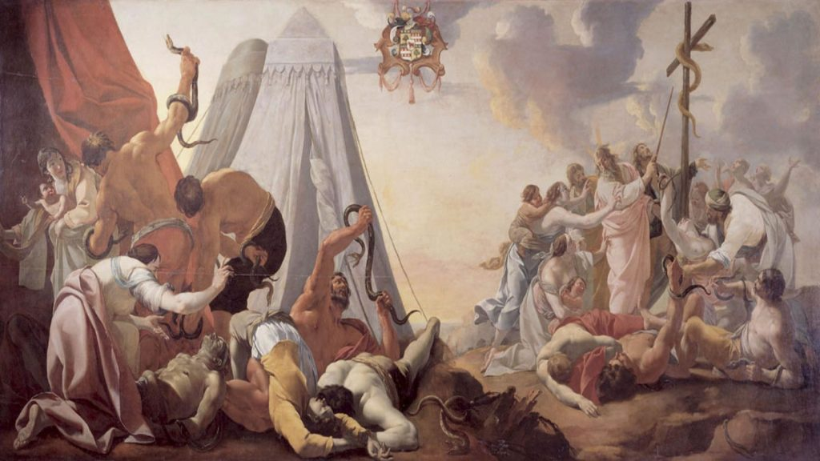
Week Five – Study Guide
N.T. Types and Shadows
The New Testament has it’s own types and Shadows. These are scriptures that refer back to the Old Testament.
Remember what Jesus told us about the Old Testament: Write out each verse. Then after that share why this is so important to the believer.
- Luke 24.27
- Luke 24.44
- John 5.39, 46
- Hebrews 10.7
- Why is this important?
Here are the Types and Shadow from the New Testament referring to the Old Testament. Write out each verse. Share why this is important for believers today to know each of these. Finally answer the question after the verses.
- Matthew 12.40
- John 3.14
- John 6.32-33
- Romans 5.14
- 1 Corinthians 5.7
- 1 Corinthians 10.4
- Hebrews 10.20
- Hebrews 11.17-19
- Why is the Old Testament important to the Christian believer today? There are many answers to this question so let your thoughts run free.

